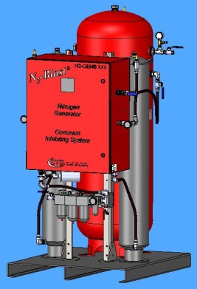
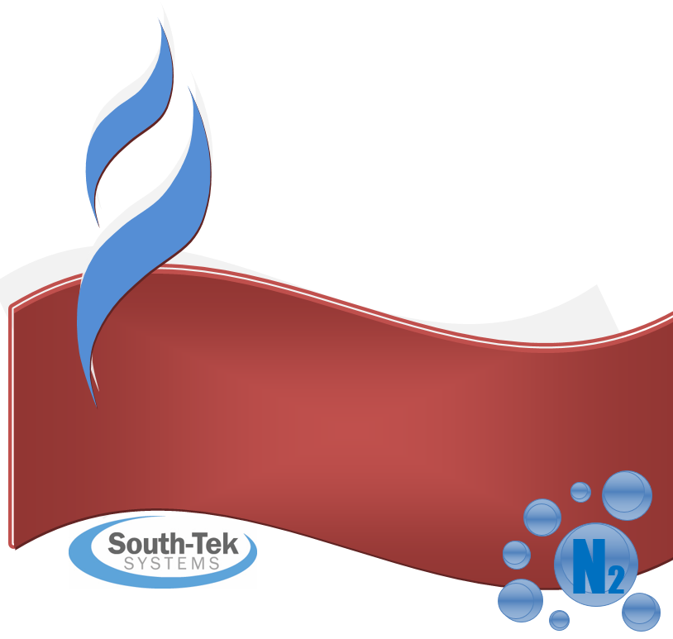
N2-Blast®
FPS-15000 & FPS-20000
Installation, Operation &
Maintenance Manual
South-Tek Systems
Version 3
COPYRIGHT 2016

2940 Orville Wright Way Suite #600 • Wilmington, NC 28405
Tel (888) 526-6284 Fax (910) 332-4178
Email: info@southteksystems.com

Table of Contents
1. Introduction 5
1.1 About South-Tek Systems 6
1.2 Equipment Safety and Handling Information 7
1.3 Room Ventilation Recommendation 8
1.4 Limits of Liability 8
1.5 Warranty 9
1.6 Service Return Policy 9
2. Receiving, Unpacking, and Storage Instructions 10
2.1 Receiving Equipment 10
2.2 Unpacking, Moving, and Securing Equipment 10
2.3 Storage Instructions 10
3. SITE AND UTILITY REQUIREMENTS 10
3.1 Air Supply 10
3.2 Additional Piping and Hoses 11
3.3 Electrical Supply 11
3.4 Site Specifications 11
3.5 Outdoor Package Units (only on certain models)** 12
4. SYSTEM INSTALLATION 13
5. SYSTEM DESCRIPTION 14
5.1 Specifications 14
5.2 Standard Controls and Instrumentation Overview 14
5.2.1 Power Switch/Power Light Indicators 14
5.2.2 Hour Meter / Running Data 15
5.2.3 Pressure Transducer Setup 15
5.2.4 Sieve Bed Pressure Gauge 17
5.2.5 Tank Pressure Indicator 17
5.2.6 Inlet Air Pressure Regulator Gauge 17
5.3 Filters 18
5.4 PLC 19
5.4.1 Alarm Settings 19
5.4.2 Calibration Procedures 20
6. PRINCIPLES OF OPERATION 22
7. GENERATOR OPERATION 23
7.1 Start-Up 23
7.1.1 Initial Start-Up 23
7.1.2 Normal Start-Up 24
7.2 Shutdown 24
7.2.1 Emergency Shutdown 24
7.2.2 Normal Shutdown 24
8. BlastOff™ - Leak Detection System (Optional) 25
9. MAINTENANCE 26
9.1 Power Issues 26
9.2 Incoming Air Filtration 26
9.3 Rebuild process valve 28
9.4 Nitrogen Generator 28
10. TROUBLESHOOTING 29
Appendix A: Customer Equipment Layout/Connection Drawing 31
Appendix B: Specifications 33
Appendix C: Warranty 34
Appendix D: APS Installation 35
35
Appendix E: Quick-Check Fixed Mount Connections 36

Introduction

South-Tek Systems welcomes you to the exciting world of Nitrogen Generation! We provide leading edge technology in Pressure Swing Adsorption (PSA) type Nitrogen Generators that allow you to produce Nitrogen at your own facility. Our technology allows you to reduce your N2 gas costs by as much as 90% versus purchasing from a gas supplier. We develop PSA systems worldwide that are utilized in industrial, lab, and military settings. We pride ourselves with our abilities to communicate and engineer Nitrogen Generation systems to meet specific requirements of our customers!

Here at South-Tek Systems, we engineer simple, turnkey generators to provide cost-effective means of producing your own nitrogen gas. Our technology is based on years of R&D on how to most effectively utilize Carbon Molecular Sieve (CMS) to filter the nitrogen from the other gases in the air. We use the highest quality CMS provided to the market which goes through extensive in house quality testing procedures. Our design principles require clean dry compressed air being delivered into two pressure vessels packed with CMS. We’ve engineered our systems to provide our customers with years of confidence and reliability in the nitrogen generator with the proper maintenance and care.

Each Nitrogen Generator comes individually tuned, pre-tested and certified to meet the customer’s specified nitrogen flow rate and purity using our Data Acquisition System (DAS). Our certification provides the necessary criteria to replicate a successful field installation. Our systems are turn-key with detailed drawing, manual, and phone/text support. We also have field service, commissioning, and other engineering services available.

The N₂-BLAST® provides an economical, precise means of generating high purity nitrogen. Since air is comprised of ~79% N₂ we simply and cost-effectively separate the N₂ from the air. Nitrogen is an inert gas (non-combustible) and widely used in thousands of industries along with Fire Protection Systems. The N₂ is “generated” by means of our PSA technology.

* * * Read before installing and operating the N₂-BLAST® * * *

All personnel (and their supervisors) installing, operating, and maintaining the N₂-BLAST must read and fully understand this manual prior to installing, operating or performing maintenance on the system.

The N₂-BLAST produces Nitrogen (N₂) at a low flow rate, which quickly dissipates into the air. N₂ gas is not poisonous but the gas should not be directly inhaled, since in high concentrations, they can cause asphyxiation. Ensure that the unit is installed within a well-ventilated room, one that is not sealed off from normal living space air changes.

All personnel involved with installation, operations, and maintenance of the N₂-BLAST must follow safe working practices, OHSA, and local health/safety code regulations during the installation, operation, and maintenance of the unit.

Electrical Requirements: Connect the N₂-BLAST to an electrical supply following all local safety regulations. Ensure the unit is supplied with 110V/60hz power rated at 20 amp service. The unit must be grounded.

Servicing the N₂-BLAST. Before personnel attempt to service the unit, ensure the power switch has been turned to the off position, then disconnect the unit’s external power cord from the building electrical power supply. Always follow specific manuals from STS when servicing your system.

About South-Tek Systems

South-Tek Systems, founded in 1997, is a Nitrogen Generator manufacturer, designing and producing Nitrogen generating systems for worldwide distribution.
Why not generate Nitrogen at your own facility for a fraction of the cost versus endlessly paying for bulk liquid or delivered gas cylinders? We manufacture a full line of Nitrogen generating equipment including:

- The N2 GEN® Series with generators ranging from the compact 1 LPM table top lab generator on up to the 50,000 SCFH unit
- The BeerBlast™ Mixed Gas Dispense System for restaurants and bars seeking the perfect draft pour
- The TireBlast™ Nitrogen Tire Filling System for automotive and tire shops seeking optimal tire pressure maintenance and fuel economy

With purities ranging from 95% up to 99.999%, we provide Nitrogen Generators that are sure to suit your needs. Plus we design and manufacture our patented Leak Detection system to work with compatible generators for optimum safe operation.

For more information about our complete Nitrogen Generator capabilities, please visit www.southteksystems.com.

Equipment Safety and Handling Information

The following section outlines the basic safety considerations regarding use of your Nitrogen Generator. For additional safety information regarding other equipment used in conjunction with the nitrogen generator, such as air compressors, dryers, boosters, etc., please refer to individual manufacturer recommendations and technical guidelines.

Read carefully and act accordingly before installing, operating or repairing the unit.

- The operator must employ safe working practices and rules when operating the nitrogen generator.

- The owner is responsible for maintaining the unit in a safe operating condition.

- Always use approved parts when performing maintenance and repairs. Make sure that replacement parts meet or exceed the pressure requirements.

- Only authorized, trained and competent individuals must perform installation, operation, maintenance and repair.

- Completely depressurize the generator, tanks, and lines prior to performing any mechanical work, including changing the filters. The nitrogen must be vented to the outside or to a large, well-ventilated room to avoid suffocation due to lack of oxygen.

- Safety glasses should be worn if the cabinet door is open while the machine is operating.

WARNING
Pressurized gases are contained within the generator, the receiver, and product tanks. High-pressure gases are dangerous and may cause injury or death if handled or used inappropriately.

- Never allow high-pressure gas to exhaust from an unsecured hose. An unsecured hose may exhibit a whipping action, which can cause serious injury. If a hose should burst during use, immediately close all isolation valves.

- Never disable or bypass any safety relief valves on the air receiver or product tanks.

- Always make certain that the nitrogen generator is unplugged prior to performing any electrical work.

NOTE
If any statement or specification within this booklet, especially with regard to safety, does not agree with legislation or standard industry practices, the more demanding shall apply.

All personnel involved with installation, operations, and maintenance of the PSA Nitrogen Generator must follow safe working practices, OSHA, and local health/safety code regulations during the installation, operation, and maintenance of the unit.

Warning:
- This manual must be read in its entirety prior to installing and operating the generator to prevent accidents and damage to the generator
- Contact your supplier if you detect a problem that you cannot solve with this manual.
- Only use the generator in accordance with its designed purpose.
- Only service-engineers, that are qualified to work on electric and pneumatic equipment, are allowed to do the installation, maintenance and repairs. Unqualified people are not allowed to repair the equipment.
- Do not tamper or experiment with the equipment or exceed the technical specifications

Room Ventilation Recommendation
The nitrogen generator will exhaust a slightly higher oxygen (O2) to nitrogen (N2) concentration than normally found in air. Typically concentration will be between 20.9 to 40% O2 balance with N2. The volume of gas exhausted to the room is approximately equal to bed’s pressurized volume at 50% of the incoming air pressure to the generator every minute. For example, let’s assume the bed volume at atmosphere is 10 cubic feet, and the incoming air pressure is equal to 100 PSIG, then the calculations are as follows:
100 PSIG x 50% = 50 PSIG, then convert PSIG to PSIA,
50 PSIG +14.7 PSIG = 64.7 PSIA, then convert to ATM,
64.7 PSIA / 14.7 (PSIA/ATM) = 4.4 ATM, then calculate total volume stored,
4.4 ATM x 10 cubic feet/ATM = 44 cubic feet, then consider this once every minute,
44 cubic feet / 1 minutes = 44 standard cubic feet per minute vented from the unit.

Limits of Liability

Buyer's exclusive remedy for all claims shall be for damages, and seller's total liability for any and all losses and damages arising out of any cause whatsoever including, without limitation, defects in or defective performance of the system, (whether such claim be based in contract, negligence, strictly liability, other tort or otherwise) shall in no event exceed the purchase price of the system in respect of which such cause arises or, at seller's option, the repair or replacement of such; and in no event shall seller be liable for incidental, consequential or punitive damages resulting from any such cause.

Seller shall not be liable for, and Buyer assumes all liability for, the suitability and the results of using Nitrogen by itself or in any manufacturing or other industrial process or procedure, all personal injury and property damages connected with the possession, operation, maintenance, other use or resale of the System. Transportation charges for the return of the System shall not be paid unless authorized in advance by Seller.

NOTE
Any MODIFICATIONS made by the customer without the consent of South-Tek Systems will void the product purity and output specifications.

Warranty

The Nitrogen Generator, excluding the air supply system, is warranted against defects in materials and workmanship, under normal use and operation, as applicable in the warranty listed below. All compressors, booster, dryers, and/or other 3rd party equipment are covered by their original equipment manufacturer's warranty.

The South-Tek Systems’ Warranty includes the following:

Free repair or replacement of component parts where defects occur within the first twelve (12) months of operation or twelve (12) months from the date of invoice, whichever comes first.

These warranties shall be null, void, inoperative, and not binding upon South-Tek Systems if a defect or malfunction occurs in the product or any part thereof from any feed air malfunction, or improper filter element maintenance, or repair, attempted repair, adjustment or servicing by anyone other than an authorized representative of South-Tek Systems, or external causes. Said warranty shall extend and apply to the Nitrogen Generator only while said system is owned and used exclusively by the original purchaser.

NOTE
THERE ARE NO EXPRESS WARRANTIES BY South-Tek Systems, OTHER THAN THOSE SPECIFIED HERE. NO WARRANTY OF TITLE AS PROVIDED IN THE UNIFORM, COMMERCIAL CODE SHALL BE IMPLIED OR OTHERWISE CREATED UNDER THE UNIFORM COMMERCIAL CODE, INCLUDING BUT NOT LIMITED TO WARRANTY OF MERCHANTABILITY AND WARRANTY OF FITNESS FOR A PARTICULAR PURPOSE.

Service Return Policy

If it is necessary to return a system for service, follow the procedure given below. This procedure must be followed when returning a system for service.

- If the system cannot be repaired at the site, then the owner must obtain a written Return Material Authorization number, which references the model and serial number, from South-Tek Systems. No items will be accepted for service or credit unless prior written authorization has been issued by South-Tek Systems.

- All items are to be returned with the original packaging material if possible. Make sure that all items are packaged for safe return to South-Tek Systems. South-Tek Systems will not be responsible for damages, which occur in transit. Any damage that occurs to the system because of failure to adhere to this procedure will be the sole responsibility of the customer. Contact South-Tek Systems for a return shipping address.

- Shipping charges must be prepaid on all returns.

Receiving, Unpacking, and Storage Instructions

Receiving Equipment

The Nitrogen Generator(s) and all components are securely packed to minimize possibilities of damages during shipment. The contents of the crate(s) should be inspected upon delivery to assure that no damage has taken place during transit. Save the carton and wrapping, as it may be necessary to return the generator in event of shipping damage. If any components are found to be damaged, the carrier should be notified immediately. The individual pieces should be checked against the packing list. If any discrepancy is found, contact your local distributor or South-Tek Systems at (888) 526-6284. Please include the model number and the serial number with all correspondence.

Unpacking, Moving, and Securing Equipment

The FPS-15000 and FPS-20000 are placed upright and securely bolted down inside of a wooden crate. Removal of these style generators is easily accomplished by opening the wooden crate and unbolting the unit from the crate. To lift the Nitrogen Generator out of the box, insert forks through the open slots on the bottom of the generator.

Once the equipment is moved to its final destination, it is recommended to anchor the equipment to the ground. Please follow any guidelines associated to your site in safely securing all equipment.

Storage Instructions

If the unit is not to be installed until a later date, a safe dry storage location is needed, preferably inside a controlled environment. Desiccant packets need to be put into the cabinet to keep moisture out of the electronics. Do not store around moving objects that could fall or damage the unit. If the unit is kept in storage for a long extended time (over 1 month), then the Oxygen Fuel Cell/Analyzer should be removed, tapped off, and stored in a controlled environment.

SITE AND UTILITY REQUIREMENTS

The following requirements must be met to enable the nitrogen generator to perform at its rated capacity. Deviation from these requirements may result in poor performance, injury to persons or machinery, and voiding of warranty.

Air Supply

Air supplied to the generator must be between 100 °F / 38 °C and 33° F / 0.5 °C, with a water dew point of 40°F / 5°C or below. Air at temperatures higher or lower than this may cause damage not covered by warranty. Likewise, moisture content higher than that specified may damage the adsorbent material and void the warranty. Air and nitrogen pressure vessels must be compatible with the generator. Use of a correctly sized refrigerant dryer will ensure that the air supplied to the generator will meet the specified standards.

The performance of our PSA type Nitrogen Generators is based on minimum 100 psig / 6.9 bar g operating at standard conditions. Operation at higher or lower pressure will result in a nitrogen production above or below design. Operation at higher pressures than 150 PSIG may damage the media inside the pressure beds. Also, f air supply is capable of greater than 150 PSIG be sure that the delivered flow rate is less than the safety relief capacity. Consult South-Tek Systems for your safety relief capacity if your air pressure is greater than 150 PSIG. Air consumption for each Nitrogen Generator depends on nitrogen product purity and flow rate. Please consult South-Tek Systems for details.

Additional Piping and Hoses

The air supply piping components must be capable of supplying the required amount of feed air at the required pressure measured at the generator inlet connection. If the length of piping from the air receiver is greater than 50 feet, an air supply line one size larger than the Nitrogen Generator inlet air nozzle size should be used.

Electrical Supply

Power supply must be 110 V - 240 V / 50 - 60 Hz / 1 PH / 7A as labeled on the unit. Power consumption is less than 100W. Each unit is supplied with a 110 VAC USA power cord; however, obey local code to finalize your power connection to your site supply. If you are located outside the US and need to select a power cord you will need a properly rated plug for your region with a ground.

Site Specifications

Select a non-hazardous area indoors for installation which remains above 33 °F / 0.5°C and below 100 °F / 38 °C. Adequate space should be provided around the generator for access and routine maintenance. Ensure that there is enough space for the air receiver and product receiver skid next to the unit.

The exhaust piping from the nitrogen generator may be vented outside, but any additional piping used should be the same size as the exhaust piping supplied with the generator or larger depending on the length of the pipe. Exhaust piping should not have any restrictions or valves, and should be as short as possible.

Outdoor Package Units (only on certain models)**

Our Outdoor Package allows for our Nitrogen Generators to be installed outdoors with limited protection from the elements. It is highly recommended that a roof and or walls help shield from driving rains when possible.

The Typical Outdoor Package upgrades:

- See your project quote and specifications for specifics
- The N2 Generator’s electronics cabinet to a NEMA4 cabinet.
- When equipped with a oxygen analyzer, the cabinet has a N2 Purge coming back from the N2 storage tank which allows it to maintain a very low dew point which keeps the cabinet dry within. Always keep the cabinet closed tightly to protect the internal components. This helps the electronics to stay within their operational range of -5°C to 40°C with a Relative Humidity of 10%-90% non-condensing.
- A Valve cabinet with NEMA4 style doors and limited openings protect the pneumatic valves which control the air and N2 through the N2 Generator.
- The specified valves can handle temperatures from -5°C to 50°C ambient temps with dry air passing through them.

SYSTEM INSTALLATION

This section provides a step-by-step procedure for easy installation of the Nitrogen Generator with optional air supply system and tanks.

- Follow the instructions for unloading/unpacking the Nitrogen Generator described in Section 2.2.

- Position the nitrogen generator in an area as described in Section 3.4. Lift the nitrogen generator carefully to avoid damaging piping or control system.

- Review the supplied customer “Equipment Connections Drawing” (See Appendix A: Customer Equipment Layout/Connection Drawing) for detailed layout instruction design for your specific equipment. This may include a combination of an air compressor, dryer, air cooler, air receiver tank, nitrogen generator, nitrogen storage tank, and nitrogen booster.

- Carefully lift the equipment(s) and position them in a manner that is most suitable to the customer site conditions. Use lifting and strapping devices that are rated to move the equipment. It is recommended that the nitrogen storage tank should be located as close to the nitrogen generator as possible.

NOTE:
Carefully attach lifting devices and any rigging to limit heavy impacts and jolting motions which may damage the piping and valves within the system.

- Install the air compressor and refrigerant dryer (if supplied) in accordance with the manufacturer’s instructions. Attach air supply connections to the Nitrogen Generator. Install suitable piping or hoses from the compressor to the dryer, from the dryer to the air receiver, and from the air receiver to the Nitrogen Generator. The connections may be "hard plumbed" by the user, if desired.

NOTE:
Use of piping sizes smaller than the recommended size will significantly decrease system
performance.

WARNING
Use only materials with compatible pressure rating on components on the product pipe lines.

- Install relief valve on the air receiver and nitrogen receiver if not provided by South-Tek Systems.

- Check all fittings for leaks using a leak detecting solution.

- A qualified electrician should install all electrical connections and the electrical power supply. Plug the nitrogen generator into an approved outlet of the correct voltage and frequency. Connect the optional compressor(s) and dryer to an appropriate power supply (according to the requirements stated on the motor nameplate).

SYSTEM DESCRIPTION

Specifications
The table below is a general specification for standard nitrogen generators. Refer to specification project documents for specific details of the unit.

Table 1: Specification Table
General Specifications (see Unit Detail Drawing for Specific Design Data)
Nitrogen Purity | 95-99.999% (purity is set at factory)
Installation | Floor standing, Skid Mount
Display | 3.5” Full Touchscreen
N₂ Operating Pressure | 60-100 PSIG (contact STS for options outside this range)
Cabinet Port Connections | NPT Female
Electrical | 110-240V / 50-60Hz / 1Phase; < 2 Op Amps
Ambient Temperature | 40° to 104°F (4° to 40°C)
Noise Level (dbA) | < 90 dbA
Sieve Bed Design Pressure | 150 PSIG
Storage Tank Design Pressure | 140 PSIG

Standard Controls and Instrumentation Overview

Each of our three types of generators, (Tank Mount, Cabinet, and Skid Mounts) all comes standard with certain controls and instrumentations. This section describes the function of the major controls and instrumentations associated with our standard nitrogen generators. Do not attempt to alter any controls or instrumentations; any changes without the consent from South-Tek Systems will void the performance specifications unique to your system.

Controls for supporting equipment, such as the compressor and dryer, are not included in this section. Please consult the original manufacturer’s instructions for further information.

Power Switch/Power Light Indicators

The power switch is built into the Unitronics Touchscreen located in the upper left corner. It is the main switch that controls powering on the nitrogen generator. The “Green Indicator” is lit when the unit is “ON”, and the “Red Indicator” indicates “OFF”.

Touching the indicator for 2 seconds will manually change the states from ON/OFF position. A manual stop will stop the PSA cycling. Nitrogen production will stop; airflow flow from optional air receiver does not need to be stopped as the Nitrogen Generator will internally stop the delivery of airflow.

The PSA System Status can be viewed in the lower left corner. The “Green Run” indicates system operation, the “Red Stop” indicates a manual stop, and the “Amber Standby” indicates the system in standby mode. The “Standby Mode” is automatically programmed to enter the standby state once Nitrogen Storage Pressure is achieved. In standby, the unit will pause the PSA cycling until it is ready to re-enter the operating state. See below for an illustration of the power switch and system status indication.

Figure 1: Power Switch/System Status

Hour Meter / Running Data

From the “Main Screen”, the user can access the “Run Hour” and graphic displays of the O2% content and N2 Storage tank pressure. To do so, touch the icon labelled “Graph” (see Figure 1). The bottom left shows the total run hours. The graph shows the current running O2 %. To see the N2 Tank pressure, click on the green PSI button to switch the graph (See Figure 2).

Figure 2: Graph Menu
Data is collected continuously at a sampling rate of 1 sample every 5 seconds. Once the screen reaches 5000 data points, data is scrolled off the screen 1 data point at a time, as new data is plotted in a FIFO arrangement.

Pressure Transducer Setup

The PLC is equipped with a pressure transducer to display the current pressure of the Nitrogen in the Storage Tank. It’s tied into the PLC with a 4-20 mA signal and programmed to allow manual input of cut in / cut out pressures.

** The cut in / cut out settings are factory set and should not be adjusted without contacting South-
Tek Systems. Adjusting these settings may alter the results of the N2 purity as well as the N2 flow
capabilities.

To see what the factory setpoints are, the user can hit the “Menu” button from the main screen, then “Pressure Transducer Setup” (Figure 3). A password prompt screen will appear. Touch the blue box and a numerical keypad will pop up. Enter in the password provided by South-Tek Systems and hit enter. (See Figure 4)

Figure 3: Menu Screen
Figure 4: Password and Numeric Keypad
With the correct password, the pressure transducer screen will pop up, Figure 5.

Figure 5: Pressure Transducer Screen

Sieve Bed Pressure Gauge

Each unit is equipped with two sieve bed towers. At the top of each tower, there’s a pressure gauge to monitor the pressure changes in the beds throughout the cycle. These are used to help indicate if there’s any problem with the air going to each bed.

Tank Pressure Indicator

The PLC comes standard with a pressure indicator to display the current pressure inside the Nitrogen Storage Tank. Looking at the above Figure 1, the tank pressure can be view on the left side on the main screen.

Inlet Air Pressure Regulator Gauge

All tank and cabinet model units will come standard with the air pressure regulators inside the units. Most skid model systems will come standard with the air pressure regulators inside the cabinet as well. Some of the larger units will have the regulator install outside the cabinet. The regulator, Figure 6, will have a 2” back mount 0-160 psi gauge.

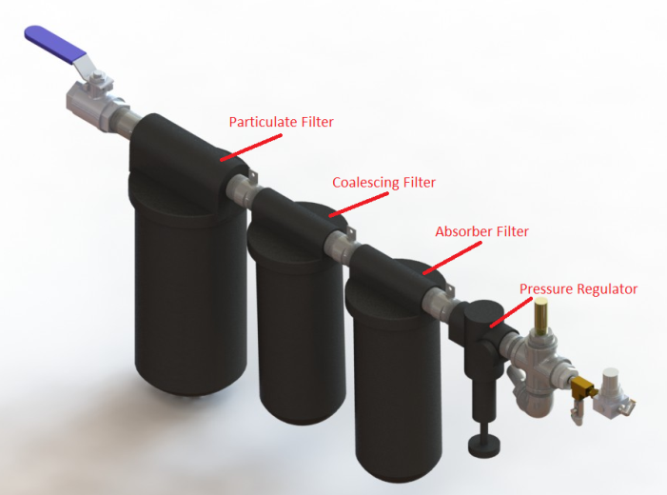
Figure 6: Filters/Air Regulator Set
The regulator will come factory set between 100-150 psi based on the customer predetermined design criteria. It is set with 150 psi on the front side (pressure coming into the regulator). Based on customer site conditions, it may be necessary to adjust the regulator to set the pressure to the correct setting. To do so, use the provided 2” pressure gauge on the regulator to set the incoming air pressure based on the site conditions. Depending on the type of regulator you have, you’ll either loosen a turn knob or a nut slightly to allow you to adjust the pressure. To increase the pressure, rotate the knob clockwise; to decrease the pressure, rotate the knob counter clockwise.

**Note – pressure should be set as close to the top of each bed swings as possible. To do this, slowly adjust the pressure and monitor the air in gauge pressure until the bed swings. Right before the bed swings, note the air in pressure and use that as your incoming air pressure setting. At the instance of the swing, the pressure will overshoot up to 15%. This pressure should be ignored and not used as your incoming air pressure setting. Also note that the output pressure of the compressor limits the maximum pressure available to the nitrogen generator.

Filters

All units come equipped with a standard filter set that includes a Particulate, Coalescing, and Absorbing filter (Figure 6). Clean filter elements are vital for good system performance. The filters remove particulates as well as liquid, water, and oil. The pre-filter (Particulate) removes particles down to 5 microns in size. It should be changed every 12 months.

The coalescing filter removes particles down to 0.01 microns in size. The life of the coalescing filter is dependent on how well the pre-filter performs its job; it will last for 12 months when the pre-filter is regularly maintained.

The activated carbon tower and/or activated carbon filter element removes oil vapor down to about 0.003 ppm. The life of the activated carbon tower and/or activated carbon filter element is dependent on the oil content in the feed air. An activated carbon tower will typically last for 12 months when the upstream filters are regularly maintained.

See Figure 7, for illustration of how to remove typical filter bowl and replacing the filter element.

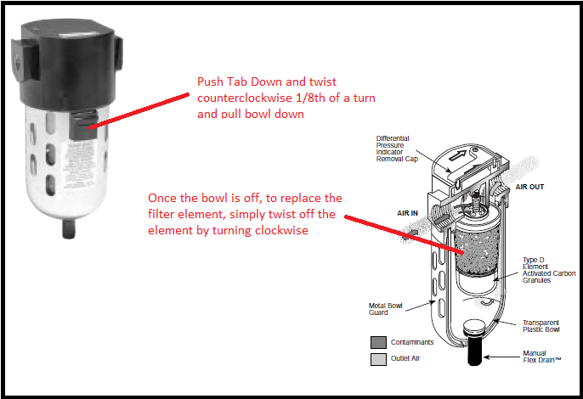
Figure 7: Filter Element Removal
**WARNING**
Do not try to remove filter bowls unless both the Air Supply gauge and the Process Pressure gauge clearly read zero psig. Turn off the power and supply air. Relieve the system pressure by opening the wedge valve after the regulator.

- Disconnect the tubes from the bottom of the bowls (if tied into condensate drain system).
- To remove the bowls, push the bowl latch down and rotate the bowl while pulling down.
- Inspect the bowls. If the drain system is working properly, the bowls should be empty.
- Replace any filter element that looks damaged or excessively dirty.

NOTE
A plugged drain system will cause water and oil to carry over into the adsorber, which will cause permanent damage to the adsorbent. Such damage is not covered by the Manufacturer's Warranty. Use of filters other than those specified by South-Tek Systems could result in damages not covered by the warranty.

- Wash the bowls in soapy water and rinse thoroughly.
- Remove activated carbon tower and replace with new activated carbon.
- Reconnect the drain tubes. Make sure the bowl latches are securely locked in place. Be careful to avoid cutting O-rings
- Slowly open the air inlet valve to pressurize the bowls. Examine for leaks and tighten if needed.

The Unitronics Touchscreen has a built in alarm screen that automatically flashes when a filter change is required (see Figure 8). The screens cannot be cleared until it has been acknowledge by the operator by hitting the “OK” button.

Figure 8: Filter Change Required Screen

PLC

Each of our three types of generators, (Tank Mount, Cabinet, and Skid Mounts) all come standard with a Unitronics Programmable Logic Controller (PLC). The program is proprietary to South-Tek and is uniquely programmed to meet the needs of individual customer engineered to ordered generators.

The PLC is used for the control sequence of the valves and controls the Nitrogen Generator’s functionality. All programs are proprietary and shall be locked from the factory. Any changes require factory assistance and must be done by STS. Unauthorized changes to the program can void all warranties and might cause damage to the system or cause it to malfunction.

Alarm Settings

Press “Alarm Params” to move to the alarm parameters menu shown in Figure 9. Setting the oxygen percent value (or ppm value if NTRON 7100 is being used), sets the oxygen output relay to ON until the O₂ percent (or ppm value if NTRON 7100 is being used) falls below the value shown on the screen.

Figure 9: Alarm Setting Screen
Once the value drops below this number, the output relay (Output relay #5) will turn OFF.

Calibration Procedures

From the home screen, press the menu button, then the sensor calibration button, which will take you to the first image seen in Figure 10. Hit the next button and then the 2 Point Calibration Menu and then select which device you would like to calibrate. O2 PPM, Max O2, and PSI sensors are the three devices you can calibrate. Calibration may be required for several reasons. One reason could be moving the unit from a lower geographical elevation to a region with a higher geographical elevation (different part of the country, or world). The oxygen sensor has an expected life time of > 900,000 oxygen % hours and should also be verified for accuracy at least once per year.

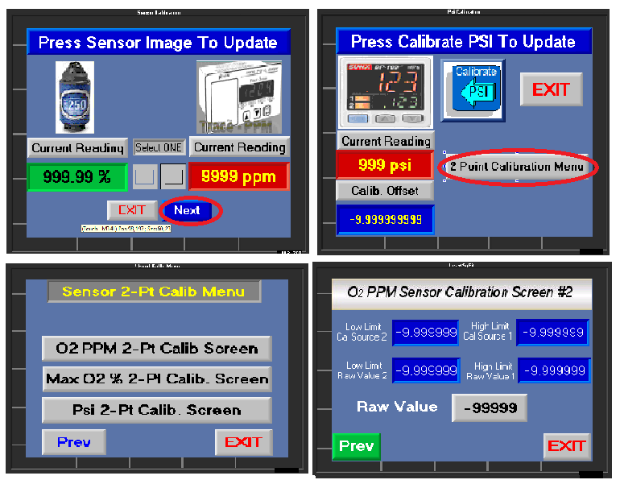
Figure 10: Calibration Screen
To calibrate the O2 PPM to read the Neutronic 7100 Analyzer installed inside the unit, you’ll need to obtain two readings, preferably with at least a 100 ppm spread. Click into the “O2 PPM 2-Pt Calib Screen” and get a reading of the PPM level on the 7100 analyzer once it’s stable. Write that value down and immediately look on the “O2 PPM Sensor Calibration Screen” and write down the “Raw Value” seen in the gray box (Figure 10). Now do the same thing once the PPM level has changed at least 100 PPM and stable. Once those values are recorded, enter them into the corresponding boxes on the “O2 PPM Sensor Calibration Screen”.

If your N2 Generator model is <99.5% N2 content, you’ll have to calibrate by selection the “Max O2 % 2-Pt Calib” option. You’ll need at least one certified known gas in the 1% O2 Range. Apply that known gas to the O2 analyzer port found on the outside of most units on the right hand side (refer to your specific customer drawing illustration for the exact location). Regulate the Calibrated gas pressure to a minimum of 5 psi and no great than 60 psi. Enter the value of that known gas as the “Low Limit Cal Source 2”. Leave the gas applied to the port until the Raw Value has stabilized. Then enter that value into the “Low Limit Raw Value 2”. Repeat this process again for a higher known certified gas, preferably somewhere around the 8% O2 range. If a second certified gas is not available, the use of compressed air will work. Just apply 20.9% (atmospheric compressed air) as the “High Limit Cal Source 1” and wait until the Raw Value settles and then enter that value into the “High Limit Raw Value 1”.

Calibrating the Pressure Transducer (reading the N2 Storage Tank) is very similar to calibrating the O2 PPM. Find the pressure transducer inside the cabinet (for most units they are located in the upper left corner where the N2 Out Port is located). You’ll need to pull two values again, one low and one high and enter in the corresponding Raw Value.

**NOTE: This process should not be done frequently. If you find that calibration is needed frequently, it’s a good indication that it’s time to change out the sensors.

PRINCIPLES OF OPERATION

The Nitrogen Generator uses state of the art technology to provide the end user with a reliable source of nitrogen. An overview of the operation of the generator is given below.

The Nitrogen Generator is a two-bed adsorber system. The Nitrogen Generator consists of two adsorber vessels filled with CMS, a valve assembly, air filters, main pressure regulator, and a product receiver tank. Dry, compressed air (~78%nitrogen, 21% oxygen, <1% argon) at 100-150 psig / 6.9 bar g and normally 68 °F / 20 °C is passed through the air filters, which remove particles and oil vapor, and then through the air inlet regulator (if supplied), which reduces the air to the final operating pressure. It is important to maintain the inlet air at the correct pressure; otherwise, generator performance may deviate from design. Clean and dry air is directed to one of the adsorber beds where oxygen and water vapor is adsorbed faster than nitrogen in the pore structure of the CMS, thus increasing the nitrogen purity of the product gas stream to the desired level (95 – 99.999% as required by customer). This product flows out of the top of the adsorber bed, through the pureflow valve, and into the product receiver at a pressure slightly below the feed air pressure.

The pressure in the adsorber vessels is equalized after a pre-factory tuned time before the next cycle starts. The beds switch roles; the first bed is purged while the second bed produces nitrogen product. The active bed will remain on-line until just prior to becoming saturated with oxygen. When the cycle is completed, the controller will exhaust the saturated bed, and pressurize the fresh adsorber bed. This allows a continuous flow of nitrogen gas from the unit for as long as the unit is in operation.

Oxygen enriched waste gas is piped to the atmosphere through a silencer. This waste gas mixes with the surrounding atmosphere and dissipates with no adverse effect.

Dry nitrogen product stream, with the specified max O₂ content, exits the adsorber vessels and is stored in a common product receiver tank (optional). Nitrogen purity and flow rate can be checked before the nitrogen is supplied to the consumer.

GENERATOR OPERATION

This section describes the procedure for starting, running, and stopping the nitrogen generator. The operator should notify personnel in the area that the generator will be started and make sure the start-up will not interfere with any other operations.

Start-Up
This section describes the necessary steps of both the initial start-up and a normal routine start-up. If this is the first time the unit has been started, follow the Initial Startup procedure.

Initial Start-Up

- Verify that power supply is 110 V or 220 V / 1 ph / 50 - 60 Hz as labeled on the unit. You can find this on the serial label inside the cabinet.

- Turn on the compressed air supply. Follow air compressor manufacturer's start-up instructions (see your air compressor manufacturer's manual). Check that air pressure is in the range of 100-150 psig / 6.2 – 12.1 barg [620-1210 kPa]. Open the air supply valve.

**WARNING**
Shut off the main air supply valve and depressurize the generator before repairing any leaks.

NOTE:
During the start-up sequence, check for leaks in all pipe-fittings and valves. Remember, even a small leak on the product nitrogen piping can severely reduce production capacity!

- Make sure the Main Power switch is in the “OFF” position.

- Plug the power cord into a properly fused and grounded electrical outlet of the correct voltage as marked on the unit.

- Turn Main Power switch to “ON”. Observe that the Unitronics Touchscreen is powered on. If it does not power on, unplug from the unit from the electrical outlet and check the fuse.

- Observe pressure gauges on the pressure vessels for one or more cycles (3 – 5 minutes). One gauge should be high and one low. The “High” pressure gauge indicates that particular vessel is being used to produce Nitrogen, while the “Low” pressure gauge indicates that particular vessel is being used to relieve other gases. Product pressure will vary with certain models based on design criteria. The “High” pressure should reach within 5 psi of the input pressure (regulated from the air pressure regulator after the 3 filters). The “low” pressure should not be greater than 10 psi at the end of the cycle.

- Nitrogen will start to flow to the product tank.

- When Product Pressure reaches the cut-out pressure (see 5.2.3), the green “Run” indicator will switch to the amber “Standby” indicator (see Figure 1) and nitrogen production will stop. When product is used and Product Pressure falls to the cut-in pressure, the “Standby” indicator will switch back to “Run” and nitrogen production will resume.

NOTE
When the nitrogen generator is turned on for the first time or after a prolonged shutdown period, it is likely that the Product Receiver is full of air. Product purity can be increased by purging the Product Receiver to safe area / outside the building for approximately 15 minutes before using the product.

Normal Start-Up

Follow this procedure to start the generator for normal operation. If this is the first time the unit has been started, follow the Initial Startup procedure, 7.1.1.

- Open the air isolation valve.

- Turn on the Main Power switch

- Open any shut off valves in the product nitrogen line to the user’s piping system. Allow the system purity to rise before using product.

NOTE
If the generator or any part of the system has been opened to the atmosphere, the system must be purged of any residual air.

Shutdown
This section describes how to perform both an emergency shutdown and a normal shutdown.

Emergency Shutdown

In case of an emergency, simply turn the Main Power Switch to OFF. This will stop all generator functions immediately. Nitrogen supply can be shut off manually closing the nitrogen product ball valve located on the product receiver tank.

Normal Shutdown

This procedure allows the generator to be restarted more quickly than execution of an emergency or abnormal shutdown procedure would.

Touch the digital power switch on the Main Screen in the top left corner (Figure 1). Proceed to valving off the nitrogen process valve after the nitrogen storage tank.

**WARNING**
The generator will remain pressurized after shut down. Before performing any maintenance or opening any piping systems, always depressurize the system. Failure to do so may result in injuries.

BlastOff™ - Leak Detection System (Optional)
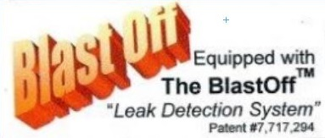
The BlastOff™ – Leak Detection System is a patented system when installed into a N₂-BLAST® will detect line leaks downstream or within the N₂-BLAST®. Line leaks could be due to a cut hose, a leaking fitting, etc. These leaks are potential safety hazards; they can cause the N2 to deplete quickly, and could cause your N₂-BLAST® system to run in excess (decreasing the life of the unit).

Once a leak has been detected, the BlastOff™ can be set to either initiate a buzzer, activate a red warning light (inserted into the N₂-BLAST® cabinet), and/or shut off the N₂-BLAST® until the problem has been remedied. To reset the BlastOff™, simply turn off the N2- GEN™ power switch and turn it back on. The N₂-BLAST® can be ordered with the BlastOff™ System Factory installed or the system can be retrofitted in the field. Some rewiring and drilling required to field install.

Factory settings will give both an audible and visual alarm as well can shut the compressor down when ordered to. The buzzer and light will continue until the system has been reset. Never reset over and over, if the BlastOff™ goes off, there is a real potential issue. Consult your installer or the factory for a solution.

The label below and the Logo above will be on your N₂-BLAST® if factory installed.

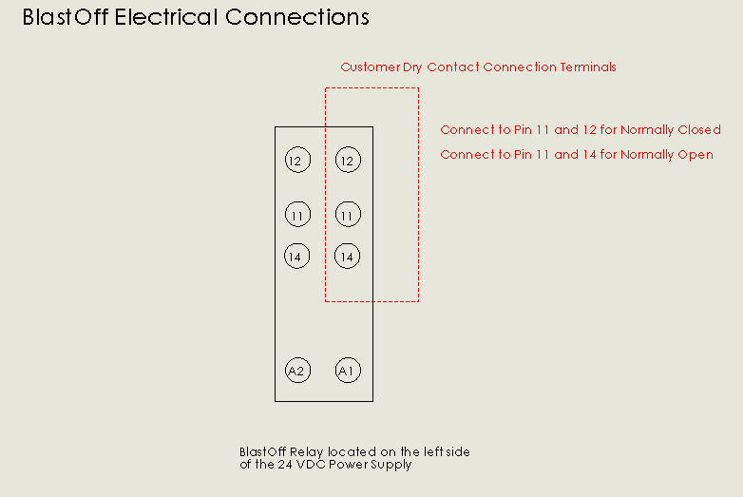

MAINTENANCE

South-Tek Systems’ Generators will provide many years of trouble-free operation if the recommended maintenance is performed thoroughly and regularly. In addition to the procedures given below, the customer must also perform all maintenance recommended by the manufacturers of the component items employed in the South-Tek Systems’ Generators. Note that where any component manufacturer specifications are different from those of South-Tek Systems, the more demanding schedule should be adopted.

**WARNING**
Read and follow all safety procedures given below and in Section 1.2, Safety Information.

Power Issues
If the generator does not have power, the production and storage of nitrogen will become apparent once the storage pressure drops.
- Check the power cord
- Check the fuse located in the fuse block. The fuse block is labeled as fuse block. The fuse is located interior to the block and is accessed by lifting the tab on the top of the block. It accepts a ¼” by 1-1/4”, 7 amp, glass time delay fuse. Max voltage of 250VAC.
- Has building’s circuit breaker or GFCI tripped? Locate the breaker and reset. If breaker continues to trip, you may have that circuit overloaded.

Incoming Air Filtration
All units come equipped with a standard filter set that includes a particulate, coalescing, and adsorber filter (Figure 6). Clean filter elements are important for good system performance. Factory recommendation on filter change out schedule are as follows:
- Particulate every 3 months (4x per year)
- Coalescing every 6 months (2x per year)
- Adsorber every 12 months (1 per year)

See figures below for illustration of how to remove typical filter bowl for a TS Series and some CS Series and replacing the filter element.
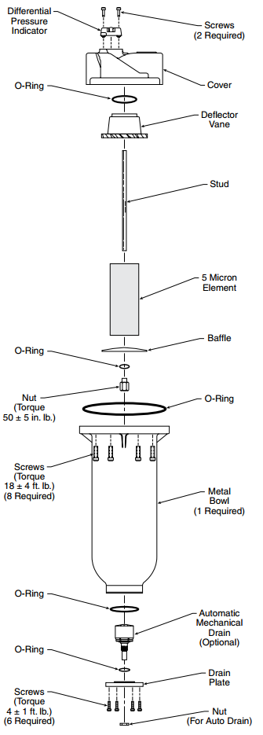
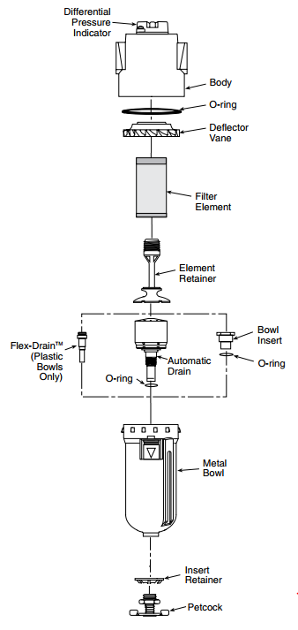

Figure 27: Filter Element Change for some CS Series and S Series
Figure 26: Filter Element Removal for all TS Series and some CS Series

WARNING: Do not try to remove filter bowls unless both the air supply gauge clearly read zero psig. Valve off the incoming air supply. Relieve system pressure by opening the wedge valve after the filters.

- Disconnect the tubes from the bottom of the bowls (if tied into condensate drain system).

- To remove the bowls from the TS and some CS models, push the bowl latch down and rotate the bowl while pulling down. To remove the bowls from some CS and S Series models, remove the screws holding the bowl to the cover, and pull the bowl off.

- Inspect the bowls. If the drain system is working properly, the bowls should not be full of water.

- Remove the filter element by unscrewing it off. Take notice of how the element looks. If the element is excessively dirty, more frequent filter changes is recommended.

NOTE: A plugged drain system will cause water and oil to carry over into the adsorber, which will cause permanent damage to the media inside the nitrogen generator. Such damage is not covered by the manufacturer's warranty. Use of filters other than those specified by South-Tek Systems could result in damages not covered by the warranty.

- Wash the bowls in soapy water and rinse thoroughly as needed. Use of light air gun to remove debris is also acceptable. Make sure to always clean and dry with a clean and dry cloth.

- Install new filter element and replace O-rings as needed.

- Put the filter bowl back on the system opposite of how it was removed making sure the bowl is seated in place correctly.

- Reconnect the drain tubes.

- Slowly open the air inlet valve to pressurize the bowls and examine for any leaks.

Rebuild process valve
It is recommended that every 5 years or 15,000 hours, that all the process valves be rebuilt. Contact South-Tek System for the specific rebuild kit parts and instructions.

Nitrogen Generator

The nitrogen generator is a rugged unit and requires only minimal maintenance. Failure to follow the maintenance schedule may result in damage to the unit and voiding the warranty.

Every day:
- Check for air and product leaks.
- Check instrument air pressure.
- Visually check control panel.
- Record nitrogen concentration and flow rate; operating or ambient temperature, feed air pressure, product tank pressure, and sieve bed pressures throughout one cycle.
- Verify that the automatic filter drain is working properly.
- Manually operate air receiver drains.

Every Three months:
- Operate safety valves.
- Operate manual valves.

Annually:
- Test all air pilot valves
- Check for air and product leaks.
- Change all 3 filter elements.
- Check O₂ analyzer sensor for proper operation as per manufacturer’s instructions and order replacement.

Three years:
- Install repair kits in all pneumatically operated valves.
- Disassemble and inspect all air-operated valves; install repair kits if required.

TROUBLESHOOTING

This section enables the operator to determine the cause of operation problems and suggests remedies for the problems. If there are several likely causes, investigate the simpler solutions first. Regardless of the type of malfunction, a person who is thoroughly familiar with the system should perform the troubleshooting procedures. If further assistance is required, contact your local distributor or South-Tek Systems.

Symptoms | Probable Cause | Corrective Action
Nitrogen Generator Not Cycling | Low Voltage or Low Amperage | Check Electrical Source
 | Circuit breaker tripped | Reset circuit breaker
 | Fuse Blown | Replace fuses located on the electrical terminal block beside the 24VDC Power Converter.
 | Main Power is OFF (Left button on the Home screen is Red) | Touch the Red switch for 2 seconds until it turns green.
 | Low Operator Air Pressure | Check the incoming air source as well as the internal air pressure regulator.
 | Defective Wiring | Check all wiring connections
Nitrogen Generator Running Continuously | Cut Out pressure incorrectly set | Reset the cutout pressure to factory setting
 | Defective wiring with pressure transducer to the Touchscreen | Check the wiring connections
 | Excessive N2 Leakage | Correct all N2 leakage
 | Cycle Pressure too low | Check the incoming air source pressure as well as the internal air pressure regulator.
Low N2 purity | Product flow too high | Decrease product flow
 | O2 analyzer malfunction | Replace O2 analyzer
 | O2 flow port valved off | Open the O2 sample port
 | Exhaust port plugged | Make sure the exhaust tube is free for any blockage
Not building any storage pressure | Bad Process valve | Check and make sure each individual valve is working properly.
 | Deflective wiring | Check all wiring
 | Disconnected pneumatic line | Make sure all pneumatic lines are secured
 | No Air Pressure going to the pilot valves | Make sure the pilot valves are getting adequate pressure

*****CAUTION*****

DO NOT DISCONNECT OR
TURN OFF AIR TO GENERATOR
UNLESS GENERATOR POWER SWITCH
IS TURNED OFF

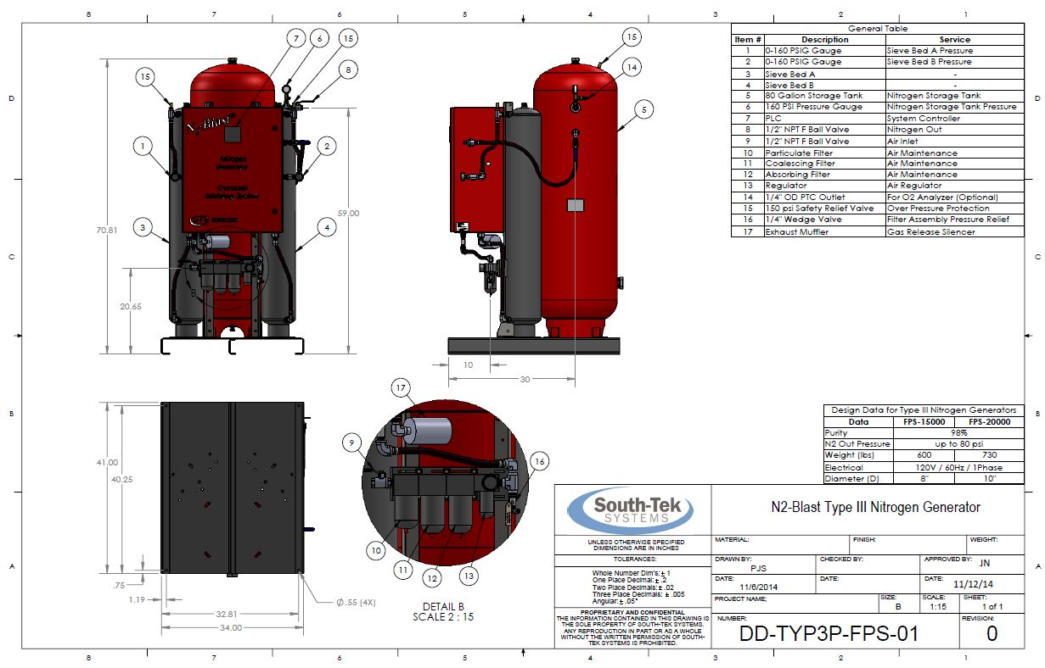
Appendix A: Customer Equipment Layout/Connection Drawing
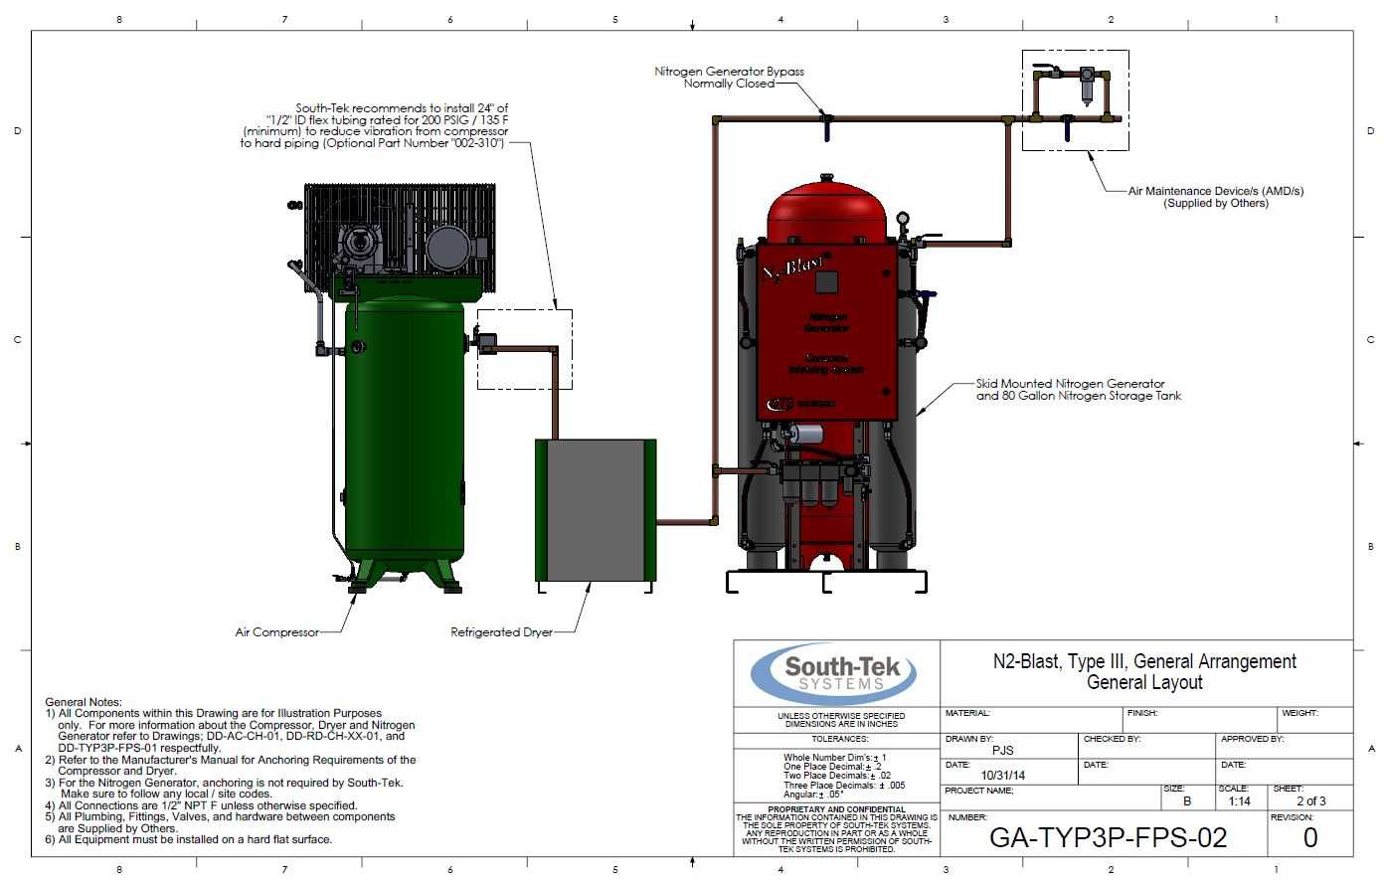

Appendix B: Specifications

 | N₂-BLAST® 15000/20000
Nitrogen purity | 98.0+%
Mounting | Floor
Display | HMI Touchscreen, LCD
N₂ Storage Pressure | Up to 80 psig (5.5 bar)
Cabinet Port Connections | ½” NPT Female
Electrical | 110-240 VAC; 7 Amp fuse
Compressor | External / Oil-free (optional feature)
Ambient Temperature | 40 to 90ºF (4.4-32.2°C)
Noise level (dbA) | under 80 (without the Compressor)
Size | 24” x 20” x 64”
Weight | 600 / 730 lbs (272/331 kg)

Appendix C: Warranty

The N₂-BLAST® System is warranted against any defects in workmanship and materials for a period of two (2) years from the date of shipment to the purchaser. The purchaser has the liability to ensure that the system is fully inspected upon delivery and shall contact the appropriate shipping company to make any claims on damaged goods due to transit within that shipping company’s policies. If the system is received with defects that are not due to shipping, a written claim should be submitted to South-Tek Systems within 1 week of receiving the shipment. South-Tek Systems can deny all other claims at their discretion.

All warranty work shall be done at a South-Tek System facility or at a N₂-BLAST® Authorized Service Center. Only factory trained and authorized personnel are covered under warranty. Any part that is returned/repaired/replaced under warranty may be remanufactured or changed to a different specification at the factory’s option. Any work performed by an unauthorized person/company or usage of non-factory parts, may void all warranties to the product.

Any item not manufactured by South-Tek may carry its own warranty from its manufacturer and will be warranted by that manufacturer. All parts that need to be returned should be announced. Any item(s) that is returned to South-Tek Systems without an RMA number (return authorization number) may be denied and returned to the sender. Contact the factory for RMA #’s, prior to return shipment.
South-Tek Systems is not liable for damages caused by normal wear and tear, water, fire, erosion, corrosion, explosion, misuse, oil/gas vapors or unauthorized modifications. South-Tek Systems is also not liable for any losses, damages, or cost of delays, including incidental or consequential damages. There are no warranties or guarantees, expressed or implied, including the warranties of merchantability or fitness for a particular purpose or use, other than those warranties expressed herein.

For Claims, contact South-Tek Systems, LLC. at:
tel (888) 526-6284 fax (910) 332-4178
Email: support@southteksystems.com
Or write to:
South-Tek Systems, Warranty Claims, 2940 Orville Wright Way, Wilmington, NC 28405

Appendix D: APS Installation

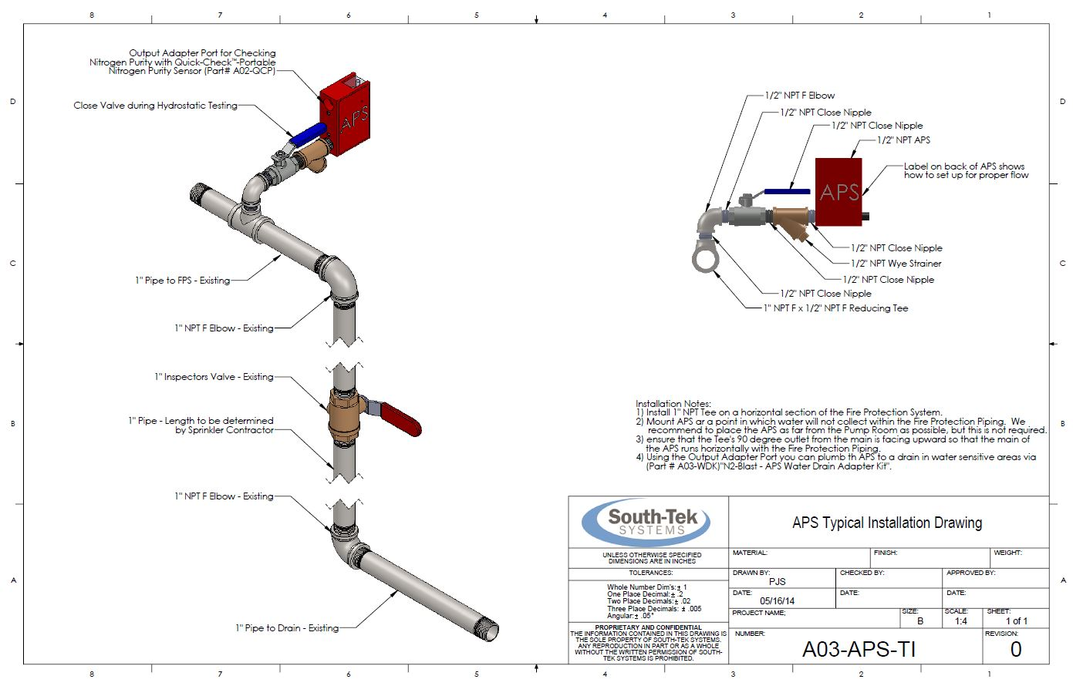

Appendix E: Quick-Check Fixed Mount Connections
