N₂-Blast® Nitrogen Generator

FPS-1750, FPS-3000 & FPS-6000

o&m mANUAL
Revision 7
Date 05/24/16
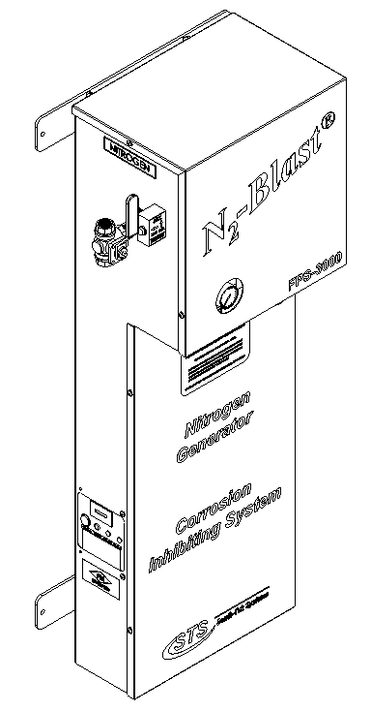
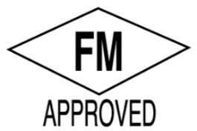

VERSION HISTORY
Revision # | Implemented  By | Revision  Date | Approved  By | Approval  Date | Reason
1 | J. Nguyen | 10/13/13 | A. Norman | 10/13/13 | Initial Release
2 | J. Nguyen | 7/5/14 | A. Norman | 7/5/14
3 | J. Nguyen | 8/15/14 | A. Norman | 8/15/14
4 | J. Nguyen | 3/6/15 | A. Norman | 3/6/15
5 | J. Nguyen | 10/15/15 | A. Norman | 10/15/15 | Bypass Added
6 | J. Nguyen | 01/12/16 | A. Norman | 1/12/16 | Updated Information
7 | J. Nguyen | 5/26/16 | A. Norman | 5/26/16 | FM Approval

TABLE OF CONTENTS
1 Introduction 6
1.1 Purpose 6
1.2 Audience 6
1.3 Important Information 6
2 Safety Guidelines 7
2.1 General 7
2.2 Service 7
3 System Description 8
3.1 Key Features 8
3.2 Specifications 9
4 Product Installation 10
4.1 Unpacking and Preparation 10
4.2 Electrical Requirements 10
4.3 Mounting (For N₂-BLAST® Nitrogen Generator) 10
4.4 Installation (For N₂-BLAST® Nitrogen Generator) 12
4.5 Panel Layout and Gas Connection 13
4.6 Blastoff™ – Air Bypass setup (Optional) 13
4.7 Check for Leaks 13
5 System Usage 14
5.1 Instructions 14
5.2 Start-Up Procedures 14
5.3 Normal Operating Procedures 14
5.4 Alarm Notification 14
6 System Maintenance 16
7 Key Contacts 18
8 FAQs 18
8.1 Power Issues 18
8.2 Pressure Issues 18
8.3 Gas Leaks: 19
8.4 BlastOff™ - Leak Detection System: 19
APPENDIX A: WARRANTY 20
APPENDIX B: Auto Purge System (APS) 21
APPENDIX c: Wiring Diagram 22
Appendix D: Installation Diagram 23
Appendix E: APS Installation Diagram 24

--------------------------------------------------Notes---------------------------------------------------

Introduction

Purpose
The N₂-BLAST® Nitrogen Generator FPS-1750, FPS-3000, and FPS-6000 (Type II Series), provide an economical, precise means of generating high purity nitrogen. Since air is comprised of ~79% N₂ we simply and cost-effectively separate the N₂ from the air. Nitrogen is an inert gas (non-combustible) and widely used in thousands of industries along with Fire Protection Systems. The N₂ is “generated” by means of the air compressor pushing air into the simple, safe membrane element, which in turn mechanically separates N₂ molecules from other molecules found within air.

**The installer and the user should read this manual in its entirety.

Audience
This manual is intended for Installer/Supervisory Staff and should be read in its entirety prior to operation.

Please contact your local distributor provider for any operation and maintenance first prior to contacting the manufacturer.

Important Information
All personnel (and their supervisors) installing, operating, and maintaining the N₂-BLAST® Nitrogen Generator must read and fully understand this manual prior to installing, operating or performing maintenance on the system.

The N₂-BLAST® Nitrogen Generator produces nitrogen (N₂) at a low flow rate, which quickly dissipates into the air. N₂ gas is not poisonous but the gas should not be directly inhaled since in high concentrations it can cause asphyxiation. Ensure the unit is installed within a well-ventilated room, one that is not sealed off from normal living space air changes.

All personnel involved with installation, operations, and maintenance of the N₂-BLAST® Nitrogen Generator must follow safe working practices, OHSA, and local health/safety code regulations during the installation, operation, and maintenance of the unit.

Safety Guidelines

General
Correct use of N₂-BLAST® Nitrogen Generator is important for your personal safety and for trouble-free functioning of the N₂-BLAST® Nitrogen Generator. Incorrect use can cause damage to the N₂-BLAST® Nitrogen Generator or can lead to incorrect gas supply.

N₂-BLAST® Nitrogen Generator produces nitrogen (N₂) at a low flow rate, which quickly dissipates into the air. N₂ gas is not poisonous but it should not be directly inhaled, since in high concentrations, they can cause asphyxiation. Ensure that the unit is installed within a well-ventilated room, one that is not sealed off from normal living space air changes.

All personnel involved with installation, operations, and maintenance of the N₂-BLAST® Nitrogen Generator must follow safe working practices, OSHA, and local health/safety code regulations during the installation, operation, and maintenance of the unit.

Warning:
- This manual must be read in its entirety to installing and operating the N₂-BLAST® Nitrogen Generator to prevent accidents and damage to the N₂-BLAST® Nitrogen Generator.
- Contact your supplier if you detect a problem that you cannot solve with this manual.
- Only use the N₂-BLAST® Nitrogen Generator in accordance with its designed purpose.
- Only service-engineers, that are qualified to work on electric and pneumatic equipment, are allowed to do the installation, maintenance and repairs. Unqualified people are not allowed to repair the equipment.
- Do not tamper or experiment with the equipment or exceed the technical specifications

Service
Before personnel attempt to service the unit, ensure the power switch has been turned to the off position, and then disconnect the unit’s external power cord from the building electrical power supply. Always follow specific manuals from STS when servicing your system.

System Description

Key Features
The N₂-BLAST® Nitrogen Generator key features include the following:
- Air Filters and Pressure Regulator
- Membrane
- Pressure Switch for Automatic Start/Stop (per demand)
- Safety Relief Valve
- N2 Storage Tank
- STS Patented Blast-Off (optional)

Air Filters and Pressure Regulator:
The generator has three filters: the particulate, coalescing, and adsorber filters. The particulate has a 5 micron filter that will catch any of the larger particles. The coalescing has a 0.1 micron filter that will catch the remaining smaller particles. Both filters feature and auto drain that will drain the water captured after the air compressor. The drain is plumbed to the outside of the cabinet where the end-user can then connect ¼” tubing and drain to a safe location. The adsorber filter captures 0.003 ppm/wt oil content.

Pressure Switch for Automatic Start/Stop (per demand):
The generator comes with a built in pressure switch to indicate when the nitrogen demand is needed or has been met. When the pressure switch is triggered (nitrogen storage tank pressure is met), it will pause the production of nitrogen to the tank. Once the pressure switch is reset (automatically reset when pressure fall 7-10 PSIG below set pressure), it will resume the production of nitrogen to the storage tank.

Safety Relief Valves:
Safety Relief Valves have been placed throughout the system for maximum safety. They are designed and put in place to minimize failure of other components. They all come with an ASME stamp.

N2 Storage Tank:
A N2 Storage Tank is housed inside the cabinet with manual ball valves and gauge. It is plumbed to an external manual ball valve so that the end-user will not have to do any plumbing within the cabinet.

Patented Blast-Off Detection (optional):
The Blast-Off Leak Detection will provide the end-user with an alarm when it detects characteristics of a leak somewhere on the system. It will trigger an audible alarm, display it on the screen, and the end-user can tie into the dry contact so that the alarm can be relayed back to the Building Management System (BMS).

Specifications
Table 1: Specification Data
N₂-BLAST® Nitrogen Generator FPS-1750, FPS-3000 & FPS-6000 Specifications
Nitrogen Purity | 98.0+%
Installation | Wall Mounted
Display | Hours / Operating / Standby / BlastOffTM
N₂ Storage Pressure | Up to 80 PSIG
Cabinet Port Connections | 1/2" NPT Female
Electrical | 110V / 60Hz / 1Phase; 20 Amp Breaker
Compressor | External
Ambient Temperature | 40° to 90°F
Noise Level (dbA) | < 80 dbA
Size | 42.3’’H x 17’’W x 11.8’’D
Weight | Appx: 85 lbs

Product Installation

Unpacking and Preparation
The N₂-BLAST® Nitrogen Generator System’s cardboard carton should be carefully opened and all parts should be inspected for damage upon receipt. Identify and verify that all parts listed on the packing list are present and undamaged. South-Tek Systems (STS) is not responsible for damages that have occurred during the shipping and handling of the N₂-BLAST® Nitrogen Generator. Any visual damages should be immediately documented and reported to the shipping company responsible. Then, contact STS at (888)526-6284 to assess the damages only after the shipping company has been notified.

Until Installation:
- Store the N₂-BLAST® Nitrogen Generator in a dry and climate controlled (60-80°F) room.
- Always keep the N₂-BLAST® Nitrogen Generator in an upright position or in box as shipped.
- Do not connect the AC power cable until this manual has been read completely and all connections are made as stated within.
- Keep all gas lines dry so you don’t get moisture in the generator upon hookup.
- Never place/stack objects on top of the N₂-BLAST® Nitrogen Generator.

Electrical Requirements
The N₂-BLAST® Nitrogen Generator requires 110V / 60 Hz / 1ph connection rated at 20 amp service. It has a built in 20A circuit breaker and a standard 3-prong US power cord is provided for the electrical connection. The system is UL 508A ICP approved. Electrical schematic available upon request.

Mounting (For N₂-BLAST® Nitrogen Generator)
It is recommended that the N₂-BLAST® Nitrogen Generator be wall mounted using its supplied wall mounting brackets. The N₂-BLAST® Nitrogen Generator should always be installed indoors in an environment between 40° and 90° F in the upright and level position where it will not be damaged by water or moving equipment.
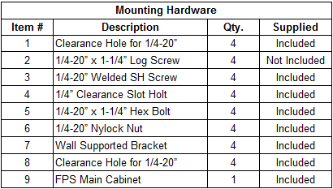
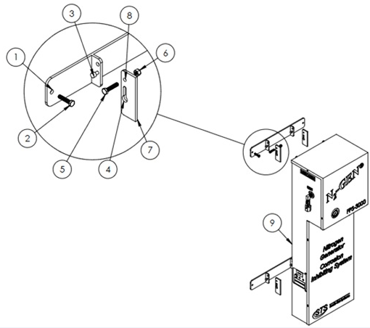
Figure 1: N2-Blast® Type II Series Wall Mount Diagram
- Install the lower mounting bracket on the N₂-BLAST® Nitrogen Generator by sliding the bracket through the keyway on the lower mounting flanges. (Item #3 into Item #4)
  - Looking at the wall bracket, the hole is installed to the top; the key (a welded bolt to the bracket) goes to the bottom.
  - Put the supplied ¼” x 1¼” bolt through the holes (2) to lock the bracket in place. (Insert Item #5 thru Item # 8 and secured with Item # 6)
- Install the upper mounting bracket on a sturdy wall. The brackets have a 16” center to center hole set for mounting to a standard studded wall.
  - Use ¼” hardware (min) to support system weight. (Item #2 into Item #1)
  - Always mount the system away from extreme heat/water/steam sources. These can cause damage to the system or persons.
- Once upper mounting bracket is installed, hang the cabinet by sliding the key through the keyway on the top flange of the N₂-BLAST® Nitrogen Generator. The system should hang level and the lower bracket can now be affixed to the wall with the same wall mounting hardware. Once the lower bracket is mounted to the wall, the system is locked into place. To remove the unit from the wall, simply take the locking bolts out and slide the system off the wall mounts.
- An 110VAC power connection should be installed per local code by a qualified electrician. See the wiring diagram for specifics. Optionally a standard 110VAC power cord can be installed on the system by a qualified electrician.

Warning: Secure the N₂-BLAST® Nitrogen Generator to the wall at the top and bottom flanges. Failure to do so could cause damage or bodily injury.

Installation (For N₂-BLAST® Nitrogen Generator)
The installation layout drawings are provided with your system in the documentation package of the system. For electronic copies, please contact your local distributor. Review and make sure the setup installations are followed per the installation layout drawings. Ensure that you follow the correction installation drawing per your system’s design. In some cases, a nitrogen bypass system for pre-filling is required in the installations to meet NFPA (National Fire Protection Association) code.
If your system requirements are more complex, please consult your sales representative or equipment installer for more detailed installation instructions.
- The N₂-BLAST® Nitrogen Generator is designed with ½” inlet/outlet connections. Use Teflon tape or similar on fittings to prevent leakage.
- Install the “Supply Line” coming from the air compressor to the N₂-BLAST® Nitrogen Generator Air Inlet.
- Connect the N₂-BLAST® Nitrogen Generator to the storage tank and then to the systems Air Maintenance Device(s).
- Once connections are made and the air compressor has been started up, slowly open the System’s On/Off Valve.
  - Air will start rushing through the nitrogen generator
  - If there is a leak or bad connection, shut valve off, depressurize the line, and fix the issue.
  - If a leak within the unit, remove top cover and locate the issue. Only use factory parts supplied from your distributor or South-Tek Systems. Consult the factory for any questions.
- Once the N₂-BLAST® Nitrogen Generator fills the nitrogen storage tank to the cut-out pressure (~80 PSIG), the system will enter standby - green light on the control panel will turn off and orange (standby) light will turn on. This will stop the air flow through the generator and eventually stop the air compressor once it reaches the cutout pressure.
  - This will save air and time on the compressor’s motor.
  - This also prolongs life of nitrogen generator’s media and filter life.
    - Lesser quality systems have a constant purge flow through their systems which decreases system life and increases the need for maintenance.
- When you draw nitrogen from the system and the tank pressure falls below cut-in pressure (approximately 72 PSIG), the pressure switch will trigger the system back into run mode and refill nitrogen into the storage tank automatically. The pressure switch is preset at the factory – no field adjustment is required.

Panel Layout and Gas Connection
Air Input is located on the left side of the unit. Nitrogen outlet will be located on the right side of the unit. Double-check all connection locations before turning on the system or opening any valves.
Note: All N₂-BLAST® models are factory equipped with ½”NPT Female connections. See drawing (DD-TYP2M-FPS and DD-A01-0100-04-04) for detail generator and tank connections.

Blastoff™ – Air Bypass setup (Optional)
The BlastOff™ - Air Bypass Option ensures that nitrogen is the only supervisory gas entering the FPS. It safeguards your installation all while providing piece of mind knowing the FPS is being filled with nitrogen vs any other gas. It will alarm if the N₂-BLAST® Generator is being bypassed by the air compressor. It safeguards against a maintenance technician from inadvertently leaving the “air bypass” open or the N₂-BLAST® being powered in the off position. It will provide a visual alarm when it is in alarm mode. See wiring diagram and installation drawing included with this package. For electronic copies, please contact your local distributor.

Check for Leaks
When a leak is suspected, first try to listen for leaks and/or spray with soapy water around the connection ports. If a leak is found, isolate the area and relieve any pressure on it prior to working on it. Fix the leaking part and return the system back to operation. If no leak are heard (or visually seen with the soapy water), turn off the unit and try isolating sections to see if there’s a pressure loss. If the BlastOff™ option is included with your unit, the system will alarm indicating that there is a leak in the line. Consult with your installer if you cannot locate the leakage area.

For more information on leak checking go to Check for Leaks.

System Usage

Instructions
The N₂-BLAST® Nitrogen Generator is intended to be used to generate nitrogen and provide nitrogen for the fire protection piping system. Follow the installation instructions above and only use in an approved environment. The generator generates enough nitrogen to maintain zone pressure requirements. Please consult with your local provider for questions not answered in this manual.

The system is design for 24 hour operation, but routine maintenance on the filters must be performed. See section “System Maintenance” for detail maintenance instructions.

Start-Up Procedures
The system is shipped ready for power once the equipment line connections are completed. Connect the pipe or hose to the nitrogen storage tank outlet using Teflon tape or other pipe connection sealant. All valves should be open and ready for gas to be distributed. Plug the N₂-BLAST® Nitrogen Generator into a 110VAC power outlet and turn on the rocker switch. The external air compressor will turn on if the N₂ storage tank is not already pressurized. If the nitrogen storage pressure is at or above the system cut-off pressure, the amber “Standby” light will be illuminated. Once the pressure drops to the cut-in pressure, the nitrogen generator will start replenishing the nitrogen into the storage tank. The “Operating” green light will illuminate until the N₂ storage tank pressure reaches the cut-out pressure (approximately 80 PSI) and the external air compressor will cut off once it reaches its cut-off pressure.
Use caution when working with pressurized gas, making sure that all fittings and gas lines are installed correctly. Always leak check (see Check for Leaks section) every line before using the system.
Note: Line leaks will cause the N₂-BLAST® Nitrogen Generator to run excessively, shortening its life and cause excess wear on the compressor.

Normal Operating Procedures
Once the generator has been started-up and the nitrogen storage tank has been filled, the system should be left power on. The system will automatic start/stop as the pressure in the nitrogen storage tank reaches the preset cut-in/out pressures. To pause or bypass the nitrogen open/close corresponding valves as necessary.

Alarm Notification
BlastOff™ - Leak Detection System Alarm
An optional feature that can be included with the system is the BlastOff™ - Leak Detection System. It is a patented system when installed into the N₂-BLAST® Nitrogen Generator, detects line leaks within the downstream gas lines from the nitrogen generator to the FPS piping. Line leaks could be due to pin-hole leaks in the pipe lines, loose fittings, faulty connection, etc. These leaks are potential safety hazards, they can cause the nitrogen to deplete quickly, and could cause your N₂-BLAST® Nitrogen Generator to run in excess (decreasing the life of the unit).

Once a leak has been detected, the BlastOff™ will sound the buzzer, and the red light on the lower left side of the cabinet will illuminate. To reset the BlastOff™, simply turn off the N₂-BLAST® Nitrogen Generator, and turn it back on. The N₂-BLAST® Nitrogen Generator, can be ordered with the BlastOff™ System Factory installed or the system can be retrofitted in the field. Some rewiring is required to field install.

Never reset repeatedly; if the BlastOff™ goes off daily, there is a real potential issue. Consult your installer for a solution. The label below and the Logo above will be on your FPS if factory installed.

Buzzer and Red Light Warning
This unit is equipped with The BlastOffTM Leak Detection System. If the red light and buzzer are on, you may have a leak in one of the gas lines. Note: To reset alarm, turn power off and close the nitrogen tank valves. Turn the power back on. If the unit goes into “Stand-By” mode and shows an orange light, the generator is operating properly and you have a leak downstream. Correct the leaks and resume operation. Contact your distributor or the mfg. as necessary. This is a safety feature designed to provide a safer operating environment and to prevent equipment damages or failure

BlastOffTM – Leak Detection System Wiring:
The BlastOffTM can be wired to an external alarm if the customer desires. The internal relay is set to trigger when there’s an alarm indication. The relay’s dry contact is configured with 11-14 termination normally open, and 11-12 are normally closed. BlastOffTM Assembly and customer dry contact relay is located in the upper left hand portion of the N₂-BLAST® Nitrogen Generator’ cabinet’s interior.

BlastOffTM– Air Bypass Option
The BlastOff™ - Air Bypass Option ensures that nitrogen is the only supervisory gas entering the FPS. It safeguards your installation all while providing piece of mind knowing the FPS is being filled with nitrogen vs any other gas. It will alarm if the N₂-BLAST® Generator is being bypassed by the air compressor. It safeguards against a maintenance technician from inadvertently leaving the “air bypass” open or the N₂-BLAST® being powered in the off position. It will provide a visual alarm when it is in alarm mode. See wiring diagram in APPENDIX c: Wiring Diagram and installation instruction in Appendix D: Installation Diagram.

System Maintenance
Servicing the N₂-BLAST® Nitrogen Generator:
Before personnel attempt to service the unit, ensure the power switch has been turned to the off position, and then disconnect the unit’s external power cord from the building electrical power supply. Always follow specific manuals from STS when servicing your system.
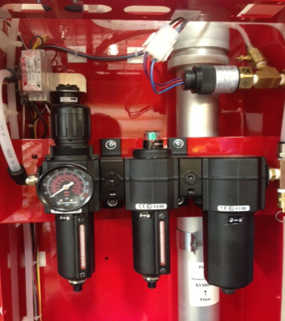
The N₂-BLAST® Nitrogen Generator utilize three different filters, seen in Figure 2 to the right. The Particulate, Coalescing, and Absorber filters must be changed out annually or every 1000 hours (hour meter located on the outside bottom right corner of the cabinet) of operating time, whichever comes first. Filter Replacement Kits can be purchased from South-Tek Systems that include the Filter Elements for the specified unit (STS Part # FRP-002).

Prior to Filter Bowl Removal

Ensure the power has been disconnected from the source. Air supply to the unit should also be bypassed, or disconnected from the unit. You can remove the top cover to the unit by removing the 4 screws that secure it to the cabinet, however it is not necessary to do this. The pressure gauge located on the regulator that houses the Particulate Filter should read 0 psi. If the pressure gauge still shows the system having pressure, you can relieve the pressure by pulling the safety Relief Valve ring located after the Absorber Filter.
Figure 2: Particulate, Coalescing, and Absorber, respectively

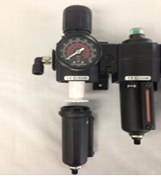
Particulate Filter Element Replacement

- Remove Filter Bowl by pressing up slightly and turning the bowl 1/8 turn to the left, then pulling down (see Figure 3). After bowl is removed you will be able to see the filter element secured in place by a threaded ring just under the element.
- Unscrew the thread counter-clockwise, and the filter element can be removed easily by pulling down.
- Install the new Particulate element and secure it in place with the threaded ring.
Figure 3: Particulate Element Replacement
- Before reinstallation of the filter bowl, be sure to clean out any debris with hot water and shake dry the water out.
- Change the O-ring on the top of the bowl with the new one supplied in the kit, use some light oil/grease if the O-ring seems to be dry.
- To reinstall the filter bowl, reverse the procedures used in removing the filter bowl.

Coalescing Filter Replacement

- Remove the filter bowl by pushing up slightly and turning the bowl 1/8 turn to the left then pulling down (See Figure 4). After the bowl is removed, you’ll be able to see the filter element still secured in place.
- The element can be removed by twisting counter-clockwise until the filter element comes completely off.
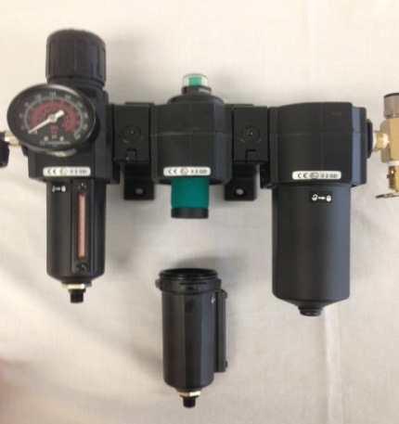
- Install the new element by twisting clockwise. HAND TIGHT ONLY!
- Before reinstallation of the filter bowl, rinse out the bowl of any debris with hot water and shake dry the water out.
- Change the O-ring on the top of the bowl with the new one supplied in the kit, use some light oil/grease if the O-ring seems to be dry.
- To reinstall the filter bowl, reverse the procedures used in removing the bowl.
Figure 4: Coalescing Filter Element Replacement
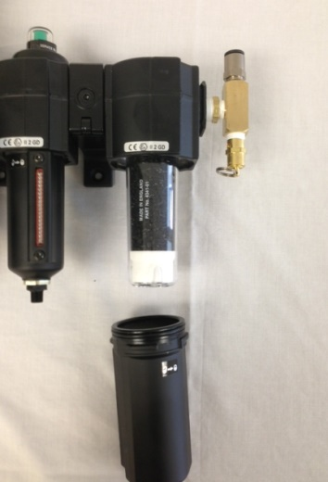

Absorber Filter Replacement

- Remove filter bowl by pressing up slightly and turning the bowl 1/8 turn to the left then pulling down (See Figure 5). After the bowl is removed, you’ll be able to see the filter element still secured in place.
- The Element can be removed by unscrewing counter-clockwise.
- Install the new element with new O-Ring by screwing clockwise. HAND TIGHT ONLY!
Figure 5: Absorber Filter
- Before reinstallation of the filter bowl, be sure to rinse it out thoroughly with hot water and shake dry.
- Change the O-ring on the top of the bowl with the new one supplied in the kit, use some light oil/grease if the O-ring seems to be dry.
- To reinstall the filter bowl, reverse the procedures used in removing the filter bowl.

Reconnecting Your N₂-BLAST® Nitrogen Generator:

- After all filter elements have been replaced, wipe down all surfaces with a clean dry towel. Do not use any cleaning agents as they could damage the finish on the filters.
- Reconnect to power source and slowly open the incoming air supply ball valve.
- After the system has been powered up, listen for any air leaks to ensure filter bowls have been adequately tightened.
- If no leaks are present, allow the system to fill up the storage tank.

Key Contacts
Contact your local provider/installer for any questions with the performance and/or maintenance of the system. They will be best suited to answer your questions and your quickest solution on any issues you may have.

FAQs

Power Issues
If the N₂-BLAST® Nitrogen Generator does not have power, the production and storage of nitrogen will become apparent once the storage pressure drops.
- Check the power cord
- Has building’s circuit breaker or GFCI tripped? Locate the breaker and reset. If breaker continues to trip, you may have that circuit overloaded.

Pressure Issues
The N₂-BLAST® Nitrogen Generator will produce and store nitrogen at 70 (+/-3) psig. Once the storage tank reaches 70 (+/-3) psig, the system will go into Stand-By Mode. When the pressure drops by about 7-10 psig, the system should go into Operation Mode and begin to refill the storage. If you are out specifications, we need to determine where the issue is. Contact the manufacturer or factory trained technician.
Nitrogen Pressure Check:
Look at the pressure gauge on the top of the cabinet. It should be between 50 and 80 psig. If the pressure is low, a few things need to be checked.
- Check the power.
- Check leaks throughout system. Refer to section “Checking for Leaks”.

Gas Leaks:
As with any gas system, only use a spray bottle on non-electrical equipment to find leaks. Fix or replace leaking fittings or old hose. Push-to-connect fittings will show bubbles and typically have up to a 5ccm acceptable leakage rate. Contact your local provider/installer for help.

BlastOff™ - Leak Detection System:
“There is an alarm sounding in the N²-BLAST® Nitrogen Generator and the control panel has Blast Off light illuminated on the side panel of the unit.”
If you hear the alarm and see the red “BlastOff light on, it means that the system is equipped with “The BlastOff™ - Leak Detection” feature. If the BlastOff is activated, there may be a leak in one of the lines, internal system components, or fittings may not be properly seated, causing gas leaks. Note: Turn off this unit’s on/off power switch and check for leaks. If none are found, leave the unit turned off and contact your local FPS contractor. Once the leak has been fixed, turn the system back “On” to resume normal operation. By turning the system power off, then back on, this will reset the BlastOff™ automatically.

APPENDIX A: WARRANTY

The N₂-BLAST® Nitrogen Generator System is warrantied against any defects in workmanship and materials for 12 months (or 1000 hours) from the date of shipment from South-Tek Systems, whichever comes first. The purchaser has the liability to ensure that the system is fully inspected upon delivery and shall contact the appropriate shipping company to make any claims on damaged goods due to transit within that shipping company’s policies. If the system is received with defects that are not due to shipping, a written claim should be submitted to South-Tek Systems within 1 week of receiving the shipment. South-Tek Systems can deny all other claims at their discretion.

All warranty work shall be done at a South-Tek System facility or at a N₂-BLAST® Nitrogen Generator Authorized Service Center. Only factory trained and authorized personnel are covered under warranty. Any part that is returned / repaired / replaced under warranty may be remanufactured or changed to a different specification at the factory’s option. Any work performed by an unauthorized person/company or usage of non-factory parts, may void all warranties to the product.

Any item not manufactured by South-Tek may carry its own warranty from its manufacturer and will be warrantied by that manufacturer. All parts that need to be returned should be announced. Any item(s) that is returned to South-Tek Systems without an RMA number (return authorization number) may be denied and returned to the sender. Contact the factory for RMA #’s, prior to return shipment.

South-Tek Systems is not liable for damages caused by normal wear and tear, water, fire, erosion, corrosion, explosion, misuse, oil/gas vapors or unauthorized modifications. South-Tek Systems is also not liable for any losses (including CO₂), damages, or cost of delays, including incidental or consequential damages. There are no warranties or guarantees, expressed or implied, including the warranties of merchantability or fitness for a particular purpose or use, other than those warranties expressed herein.

For Claims, contact South-Tek Systems LLC at:
tel (919) 847-3800 fax (919) 847-0255
Email: support@southteksystems.com
Or write to:
South-Tek Systems, Warranty Claims, 4724 Sharpstone Lane, Raleigh, NC 27615

APPENDIX B: Auto Purge System (APS)
Installation and Quick Start Guide
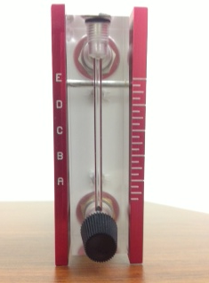
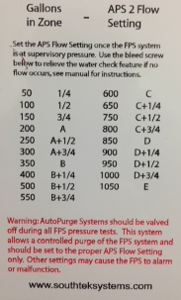
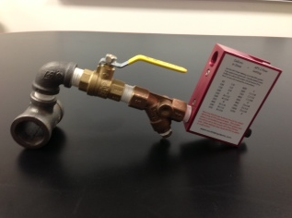
Auto Purge Assembly

Settings Label
Flow Setting Indicator

Introduction to APS:
The AutoPurge System™ is simple to install and requires little maintenance. This device provides Building Management with the assurance that high purity nitrogen is purging the entire FPS piping inner walls and reaching all distant branch locations in a timely, efficient manner. The APS is designed to distribute high purity nitrogen throughout the entire FPS, ultimately maximizing corrosion protection.

Installation:
The APS comes standard with 1” NPT Tee with female connections for installation to existing or new FPS piping. Install each APS on a high point within the system as far away from the valve room as possible on a horizontal section of piping or where water will not collect. Ensure the Tees’s 90° outlet is facing up so the main of the APS runs horizontally with the FPS piping. Be sure that during Hydro Static Testing the Ball Valve on the APS has been closed. See the installation drawing A03-APS-TI.

Settings:
There is a Label on one side of the housing that lists the proper setting for a variety of zone sizes. The Label list Gallons in Zone, vs APS Flow Setting. The Flow Setting is labeled from A-E and has three Settings in between each letter. If your zone has 500 Gallons, you would turn the knob until the floater is at letter B plus ½. Every quarter, the wye strainer needs to be checked for debris and cleaned.

Use:
Always close the ball valve on the APS when the system has planned maintenance or pressure (gas / liquid) testing. Re-open after the system is placed back online. The wye strainer should always be cleaned after water trips or system flooding.

APPENDIX c: Wiring Diagram
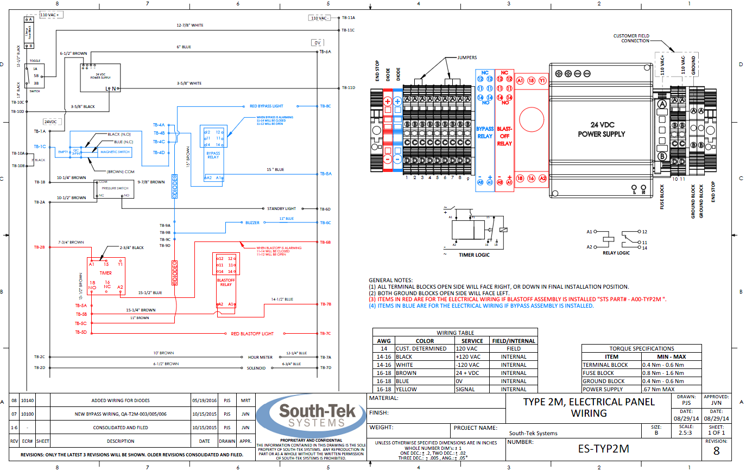

Appendix D: Installation Diagram
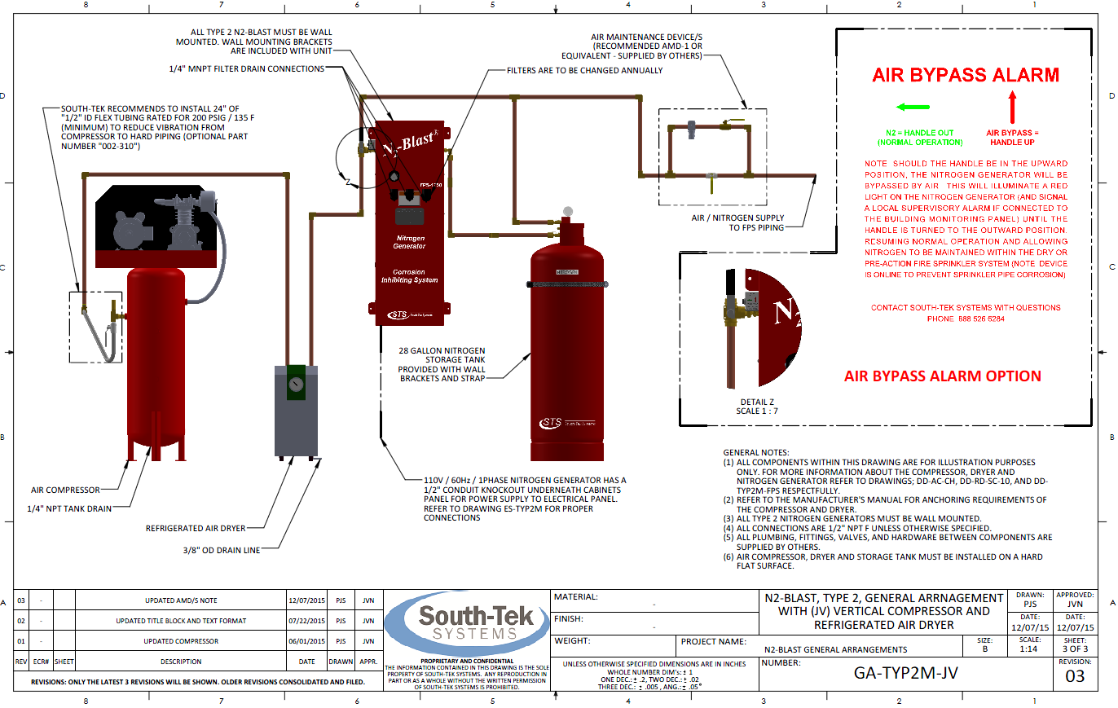

Appendix E: APS Installation Diagram
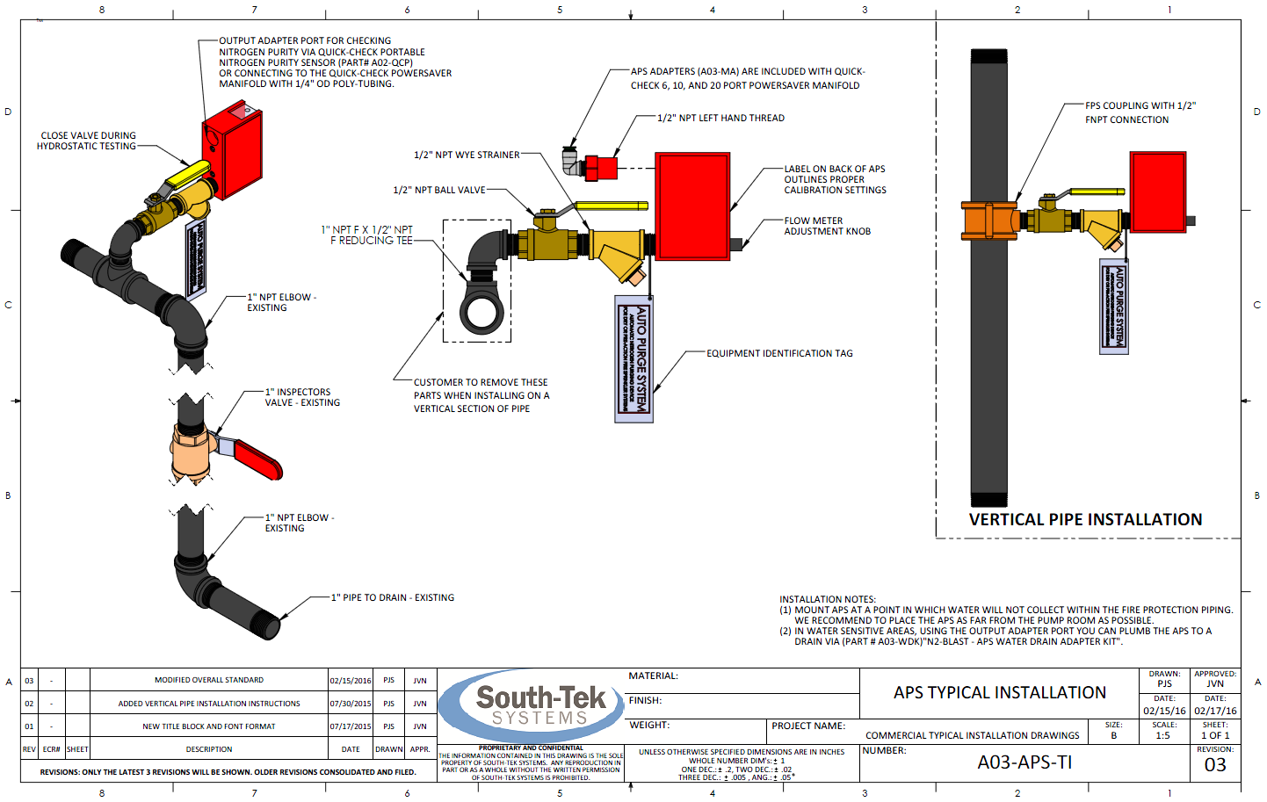

-------------------------------------------------Last Page-------------------------------------------------

